|  |
| --- |
| NetSpeed Orion Streaming Bridge Microarchitecture Specification |

NetSpeed Orion Streaming Bridge Microarchitecture Specification

About This Document

This document describes the micro-architecture specification of Streaming Bridge. This document includes feature set, block diagram, micro-architecture description, pinout and parameters used in Streaming Bridge design

Audience

This document is intended for users of NetSpeed’s Orion IP:

* NoC Architects
* NoC Designers
* NoC Verification Engineers

Prerequisite

Before proceeding, you should generally understand:

* Basics of Network on Chip technology
* NetSpeed Streaming Interface Specification

Related Documents

The following documents can be used as a reference to this document.

* NocStudio User Manual
* NetSpeed Streaming Interface Specification

Customer Support

For technical support about this product, please contact your local NetSpeed sales office, representative, or distributor.

For general information about NetSpeed products refer to: [www.netspeedsystems.com](http://www.netspeedsystems.com)

Contents

About This Document 2

Audience 2

Prerequisite 2

Related Documents 2

Customer Support 2

Acronyms 6

1 Overview 9

2 Feature Summary 10

2.1 Streaming TX Bridge 10

2.2 Streaming RX Bridge 11

3 Description 13

3.1 Streaming TX Bridge 13

3.1.1 Input FIFO 14

3.1.2 Mapping Table 14

3.1.3 Per Layer logic 14

3.1.4 Width conversion 15

3.1.5 Flow control 15

3.1.6 Output Registering 15

3.2 Streaming RX Bridge 15

3.2.1 Input FIFO 16

3.2.2 VC Arbiter 17

3.2.3 Egress per Host Interface logic 17

3.2.4 Width conversion 17

3.2.5 Flow control 17

3.2.6 Output Registering 17

4 Coarse Clock Gating 18

4.1 Streaming Tx Bridge Clock Gating 18

4.1.1 Interface busy signal from Streaming Tx Bridge 18

4.1.2 Self clock gating of Streaming Tx Bridge 19

4.2 Streaming Rx Bridge clock gating 19

5 Streaming Bridge Interfaces 21

6 Streaming Bridge Parameters 23

List of Figures

Figure 1: Orion NoC block diagram 9

Figure 2: Streaming TX Bridge 4 host interface 4 layer block diagram 13

Figure 3: Streaming RX Bridge 4 layer 4 host interface block diagram 16

Figure 4 Interface Busy signal generation per layer from Streaming Bridge 19

List of Tables

Table 1: Streaming Bridge Inputs/Outputs 19

Table 2: Streaming Bridge parameters 23

# Acronyms

|  |  |  |  |  |  |  |  |  |  |  |  |  |  |  |  |  |  |  |  |  |  |  |  |  |  |  |  |  |  |  |  |  |  |  |  |  |  |  |  |  |  |  |  |  |  |  |  |  |  |  |  |  |  |  |  |  |  |  |  |  |  |  |  |  |
| --- | --- | --- | --- | --- | --- | --- | --- | --- | --- | --- | --- | --- | --- | --- | --- | --- | --- | --- | --- | --- | --- | --- | --- | --- | --- | --- | --- | --- | --- | --- | --- | --- | --- | --- | --- | --- | --- | --- | --- | --- | --- | --- | --- | --- | --- | --- | --- | --- | --- | --- | --- | --- | --- | --- | --- | --- | --- | --- | --- | --- | --- | --- | --- | --- |
| |  |  | | --- | --- | | NoC | Network on Chip | | SoC | System on Chip | | Host | An IP core, component, or device sitting in an SoC | | Hostport | A port of a host that connects to NoC router’s injection and ejection port via a bridge to be able to inject traffic into NoC or eject traffic from NoC | | Interface | Sets of signals to receive or transmit transaction messages of a hostport; a hostport may contain multiple interfaces; each interface may be uni-directional i.e. it sends or receives transaction messages or bidirectional i.e. it both receives and transmits transaction messages | | Router | A hardware switch at the cross point of a mesh connecting to up to 4 of its neighboring routers and one or more bridges to connect to one or more hostports | | Bridge | Sits between a router’s port (often injection/ejection) and a hostport of a host to convert the hostports signal protocol (such as AMBA AXI-4) to NoC packet format and vice-versa and additional operations needed by the signaling protocol such as width conversion, etc. | | NetSpeed Streaming Interface/Protocol | Signaling protocol provided by NetSpeed NoC streaming bridges; it is a simple credit based bidirectional interface for hosts to inject and eject messages into/from NoC | | NetSpeed Streaming Bridge | Sits between a router’s port (often injection/ejection) and a NetSpeed streaming hostport of a host to convert the hostports signal to NoC packet format and vice-versa and additional operations needed by the protocol such as width conversion, etc.; there are 4 physical bidirectional NetSpeed streaming interfaces available per bridge | | Streaming Interfaces | Streaming bridge has four bidirectional interfaces named a, b, c and d | | Link/Port | Physical channel between two routers or between a router and a bridge | | Channel | Physical or virtual channel between two routers or between a router and a bridge | | Virtual Channel (VC) | Virtual channel between two routers or between a router and a bridge | | Injection channel | Incoming (with respect to NoC) virtual or physical channel at a router at which a hostport is connected to via a bridge and at which the router receives traffic from the hostport | | Ejection channel | Outgoing (with respect to NoC) virtual or physical channel at a router at which a hostport is connected to via a bridge and at which the router sends traffic to the hostport | | Cell | A node in a 2D grid or mesh; A NoC router is associated with every cell | | Node | A router or cell of the 2D NoC grid | | Virtual node | A boundary router or cell of the 2D NoC grid; in nxm mesh, there are n virtual nodes each at the top boundary and the bottom boundary in the mesh, and m at the right and the left boundary of the mesh | | Virtual router | A router at a virtual node; virtual router is connected to an adjacent internal (non-boundary) router; there is no real hardware associated with a virtual router; the hostport bridge connected to a virtual router is directly connected to the internal router’s port at which the virtual router is connected to the internal router | | Multi-layer NoC | Multiple parallel mesh NoCs each forming a layer; routers in each layer operate independently of each other; two NoC layers have no connection between their routers; a bridge at a cell connects the injection/ejection port to a router in each layer and transmits each hostport transaction message to one of the layer’s routers, and receives transaction messages from all layer’s routers delivering them to the hostport | | NoC layer | An independent NoC layer in a multi-layer NoC | | Packetization | Encoding of hostport signals into NoC packet format before they are delivered to the NoC; bridges perform packetization of hostport transaction messages into NoC packets and de-packetization of NoC packets into hostport transaction messages | | Beat | A single cycle of data part of a transaction message at an AXI-4 or streaming hostport interface | | Flit | Part of a packet that is transmitted or received at a router’s port in a single cycle | | Packet | A transaction message packetized into NoC message; a packet may contain one or many flits | | Transaction | A sequence of inter-dependent messages between various source and destination hosts/ports/interfaces. | | Hostport id | The globally unique numerical id of a hostport bridge; this is assigned by NocStudio or can be assigned by user during hostport addition; injecting transaction messages must have an associated destination in form of hostport id | | hostport name | Name of the hostport in form of hostname/portname | | interface id | This is a, b, c or d if used in context of name in streaming bridge or ld, st, st_resp and ld_data in context of name of AXI bridge; In streaming, they corresponds to 0, 1, 2 or 3 values respectively; in streaming bridge, injecting transaction messages must have an associated destination in form of interface id | | QoS id | 4-bit QoS id; each transaction has a single QoS id | | priority | 2-bit priority of a transaction; there is a 1-1 mapping between QoS id and priority which can be set in NocStudio | | weight | weight of a QoS id; this 8-bit value | |

# Overview

Orion NoC supports NetSpeed streaming bridge, which provides a relatively simple interface to the hostports and packetizes data to be transferred into NoC packets.

On a host port Streaming bridge either interfaces with the TX host interface or the RX host interface. Streaming bridge that interfaces with TX host interface is called Streaming TX Bridge and the one that interfaces with RX host interface is called Streaming RX Bridge. Streaming TX Bridge can have up to 4 host interfaces on the ingress side and up to 8 layer interfaces on the egress side. Streaming RX Bridge can have up to 8 layer interfaces on the ingress side and up to 4 host interfaces on the egress side. Each layer can further have up to 4 VCs each. Streaming bridges support same or different data widths on every interface.

Shown below is the simplified block diagram of Orion NoC.

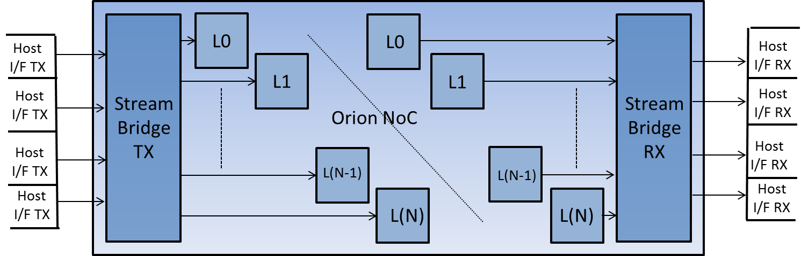

Figure 1: Orion NoC block diagram

The major components that are shown in the NoC are Streaming TX Bridge, Router layers and Streaming RX Bridge. Block also show the connectivity between Host port TX and RX interfaces.

# Feature Summary

## Streaming TX Bridge

A high level summary of features for the Streaming TX Bridge are provided in this section

* Supports up to 4 Host interfaces. Each interface implements
  + SOP, EOP, 4 QoS bits, Data beat and Data Valid, Target Interface ID, Target Host Port ID
  + Credit based flow control
  + Implements a power of 2 (e.g. 2, 4, 8) deep input FIFO on the Host side. Depth of the FIFO can be different for each host interface
* Connects to maximum of 8 layers with up to 4 VCs per layer.
  + Number of layer and number of VCs might not be power of 2. E.g. number of layers can be 1, 2, 3, 4, 5, 6, 7, 8 and VCs can be 1, 2, 3, 4.
  + Implements Credit based flow control.
* Implements fully parameterized Inputs/Outputs on Host and Router sides
* Implements 16 QoS profiles.
  + These are indexed by input QoS interface bus
  + Each Host interface accesses the same QoS profile table but with its own QoS value
  + Each QoS profile has 8-bit Weight field
  + QoS value with Interface ID and Host port ID are used to access Layer/VC/Route table
  + Weight field introduces a barrier type of packet when the weight counter expires
  + Egress packet to the router interface is marked as barrier packet from SOP, thru all data flits till EOP
* Implements a parameterized flow mapping table which provides forwarding Layer/VC/Route information
  + This is an associative table. The key {QoS value, Source interface ID, Destination interface ID, Host port ID } is compared with all the keys stored in the table.
    - If the key matches the corresponding outgoing Layer, VC and Router information is read from the table
    - If the key does not match then illegal destination flag is set and an Interrupt is raised. Illegal destination flag can be reset using the Register Bus which also resets the Interrupt
  + Each Host interface accesses the table in parallel
  + Route information from the mapping table is forwarded to the Router when the flit leaves the TX bridge.
* In each layer, host interface with a valid beat arbitrates for the layer
  + The winning host interface locks the VC of a particular layer on a SOP and unlocks it on a EOP
  + For a layer if a VC is locked by a particular host interface, another VC can be used for another host interface. Hence VC interleaving is allowed.
  + When a beat is granted on a VC, corresponding host FIFO is pop’ed and credit is returned
  + Arbiter is requested only when there is a host request, the corresponding VC is not locked and credits are available for the requested VC
* Implements Data width upsizing
  + The number of bits or width of the outgoing and incoming interfaces are individually configurable through parameters and must be in power of two multiple of cell_size. For testing minimum limit is 32/36 (depending on cell size)
  + Upsizing (data packing) is done according to Host interface data width and corresponding outgoing VC data width
  + Maximum ratio of 1:4 is supported i.e. Host interface to VC datawidth can be 1:1, 1:2, 1:3 or 1:4

## Streaming RX Bridge

A high level summary of features for the Streaming RX Bridge is provided in this section.

* Connects to maximum of 8 layers. Each layer implements
  + Up to 4 VCs.
  + Credit based flow control
  + Implements a power of 2 (e.g. 2, 4, 8) deep input FIFO per VC. Depth of the FIFO can be different for each VC
* Supports up to 4 RX Host interfaces. Each interface implements
  + SOP, EOP, Data beat and Data beat valid.
  + Credit based flow control
* Implements fully parameterized Inputs/Ouputs on Router and Host interfaces
* Implements two sets of arbiters, VC arbiter and Layer arbiter
  + VC arbiter is instantiated per layer
    - This is a priority round robin arbiter. The priorities are programmed by NocStudio
    - The winning VC also forwards the priority to the layer
    - This arbiter does not update the pointers till layer arbiter grants the VC winning request
  + Layer arbiter is instantiated per host interface
    - This is also a priority round robin arbiter. The priorities are given by VC arbiter and they are per layer
* All Hosts interface credits are maintained. At the time of reset RX Bridge starts with credits programmed by NocStudio. The credit counters are incremented when host interface returns the credits and are decremented when a valid data beat is provided to the host interface.
* Layer that wins arbitration locks the Host interface to the winning VC. The lock is enabled on SOP and released of on an EOP. On a given layer, 4 interfaces can be locked to 4 different VCs which allow VC interleaving.
* When a beat is granted for a VC of a particular layer, corresponding VC FIFO is pop’ed and credit is returned
* Implements Data width downsizing
  + The number of bits or width of the outgoing and incoming interfaces are individually configurable through parameters and must be in power of two multiple of cell_size. For testing minimum limit is 32/36 (depending on cell size)
  + Downsizing (data unpacking) is done according to corresponding incoming VC data width and outgoing Host interface data width
  + Maximum ratio of 4:1 is supported i.e. VC data width to Host interface data width can be 1:1, 2:1, 3:1 or 4:1

# Description

Bi-directional Streaming Bridge is instantiated in NetSpeed NoC IP to provide a simple interface to the SoC IP hosts. A bi-directional streaming bridge “ns_strbrdg” instantiates a streaming TX bridge “ns_strtxbrdg” and a RX bridge “ns_strrxbrdg”. Each of these bridges (TX or RX) can be disabled using parameters P_STR_TX_ENABLE and P_STR_RX_ENABLE respectively.

## Streaming TX Bridge

Figure below shows simplified schematic block diagram of TX Bridge. The configuration shown in the block diagram is of a TX bridge with 4 Host interfaces on the ingress side and 4 layers on the egress side.

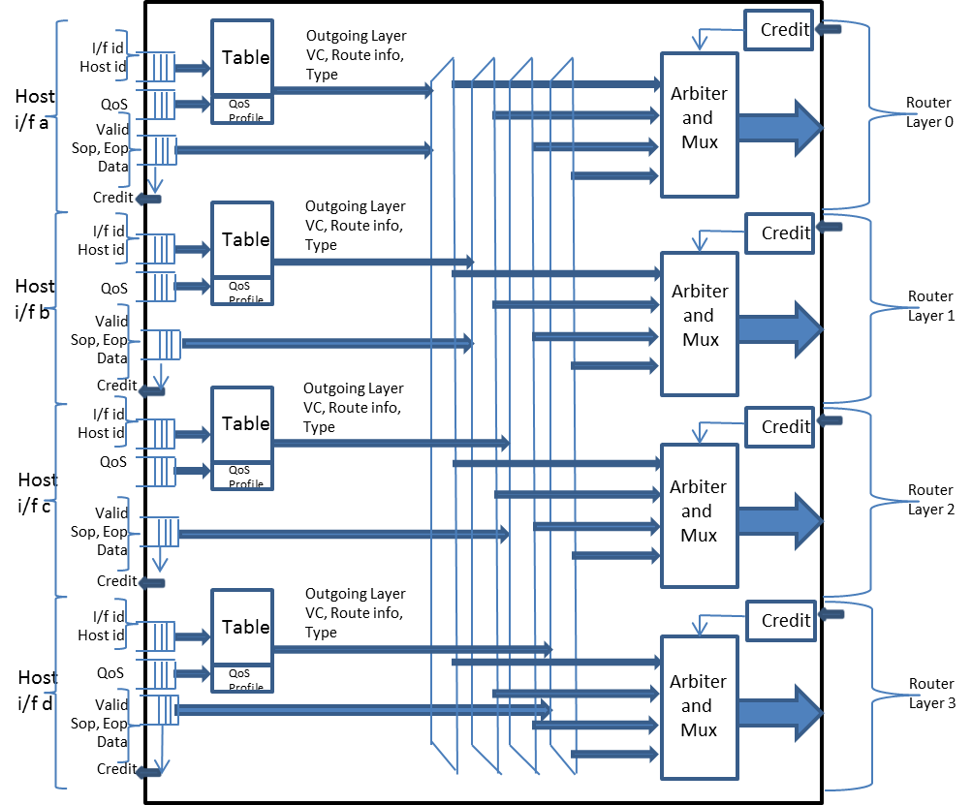

Figure 2: Streaming TX Bridge 4 host interface 4 layer block diagram

TX Bridge interfaces with the Streaming TX host port on the ingress side and interfaces with Router layers on the egress side. Streaming hostports can use up to four separate physical interfaces supported by the bridge. The interfaces are named a, b, c and d. On the egress side, TX bridge interfaces to up to 8 physical outgoing layers (block diagram only shows 4). Each layer can have up to 4 VCs each. Section **Error! Reference source not found.** shows the interface signals for host interfaces as well as layer interfaces.

### Input FIFO

Host interface signals get flopped using an input FIFO on every valid beat. There is a input FIFO for every Host Interface. The depth of each FIFO is controlled by NocStudio. The input FIFO can be optimized out if the Host interface is not enabled. In the current implementation the depth of the FIFO is a Log 2 function, therefore the depth of the FIFO can be 2, 4 or 8.

### Mapping Table

TX Bridge maps the hostport interface messages to VC and NoC layer. A mapping table is used for this purpose; the index to this table is QoS (priority) (4 bits), Source interface (2 bits), Destination interface (2 bits), and Destination hostport id (8 bits) of the message. The mapping table provides VC and NoC layer over which this message will be sent. In addition, the mapping table also provides the route information, which is used to route the resulting packet from this message.

On a valid transaction, the output of the FIFO accesses this table to get the forwarding Layer, VC and routing information. This information along with the beat valid, SoP, EoP and the data beat is then de-multiplexed to the egress layer interfaces

### Per Layer logic

De-multiplexers deliver the message (Beat valid, SoP, EoP and the Data) from all four incoming host interfaces to each layer. A round robin arbiter arbitrates between the host requests. The wining host interface acquires and locks the VC. When a multi-beat message is sent, the SOP of the message locks a VC and the EOP releases the VC. Multiple packets cannot be interleaved on a VC; however multiple VCs may be interleaved on the injection port to the router. For example, the possible scenario can be that Host interface “a” starts sending a multi beat packet and it wins the arbitration and acquires VC0 of Layer 0 i.e. Layer 0/VC0 will be locked on SOP and will be released on EOP. In parallel, Host interface “b” starts sending a multi beat packet and it acquires and locks VC1 of Layer 0, in the similar way “c” and “d” can lock VC2 and VC3 of Layer 0 respectively.

### Width conversion

TX Streaming Bridge packetizes the message beats into packet flits based on the interface width and the VC width. VC width is guaranteed to be equal to or wider than the interface width by construction. The NoC channel’s widths are configured by NocStudio based on then source and destination interface widths whose messages go over the channel. If interface width and VC width are identical, then a single message beat becomes a single packet flit. Otherwise, multiple beats of a message are combined into a single packet flit at the TX Bridge; this process is called packing or upsizing. Each hostport interface’s data width must be power of two multiple of cell_size. The maximum upsizing that can be done in TX is 1:4. There are 4 upsizing buffers per layer, which is one upsizing buffer per host interface.

### Flow control

There is a credit based flow control at both the hostport side and the router side.

### Output Registering

Output registering is NOT done in the TX Bridge, Router will register all the incoming signals from TX Bridge.

## Streaming RX Bridge

Figure below shows simplified schematic block diagram of RX Bridge

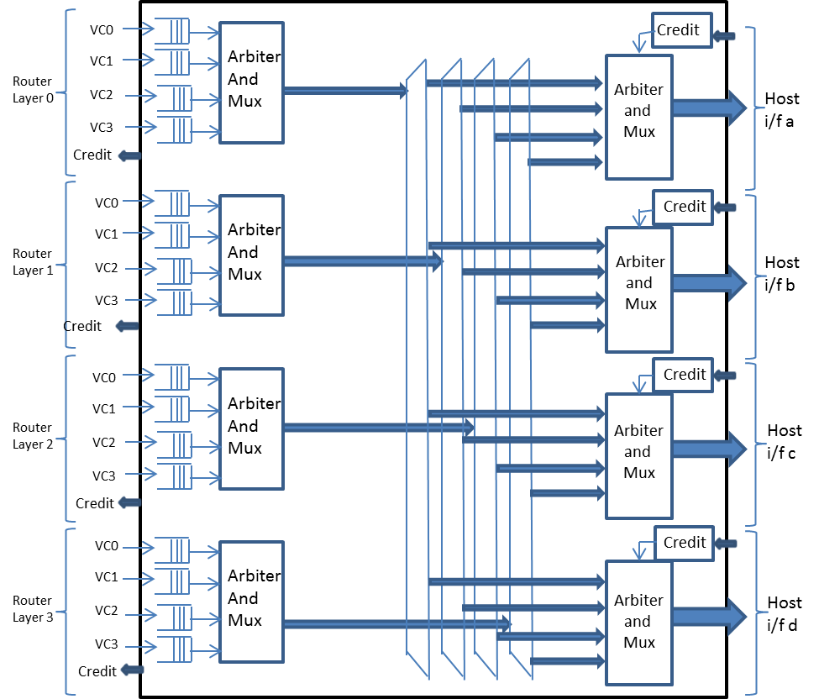

Figure 3: Streaming RX Bridge 4 layer 4 host interface block diagram

RX Bridge interfaces Router layers on the ingress side and interfaces with the Streaming RX host port on the egress side. There can be up to 8 physical incoming layers (block diagram only shows 4) on the ingress side. Each layer can have up to 4 VCs each. Streaming RX host ports can use up to four separate physical interfaces supported by the bridge. The interfaces are named a, b, c and d.

### Input FIFO

Router layer interface signals get flopped using an input FIFO on every valid flit. Since the bridge supports up to 4 VCs, there can be up to 4 input FIFOs. The depth of these FIFO is independently controlled by NocStudio. The input VC FIFO can be optimized out if the VC is not enabled. In the current implementation the depth of the FIFO is a Log 2 function, therefore the depth of the FIFO can be 2, 4 or 8.

### VC Arbiter

VC requests from the FIFO goes to a VC arbiter that is placed in each layer. This is a priority round robin arbiter. The priorities of each layer/VCs are programmed by NocStudio. The wining VC request along with the Priority, Beat valid, SoP, EoP and the Data is then de-multiplexed to all egress host interface logic.

### Egress per Host Interface logic

De-multiplexers deliver the message (Priority, Beat valid, SoP, EoP and the Data) from all incoming layers. A priority round robin arbiter arbitrates between the layer requests. The wining layer request acquires and locks host interface. When a multi-beat message is sent, the SOP of the message locks the host interface and the EOP releases the host interface.

### Width conversion

RX Streaming Bridge de-packetizes the packet flits into data beats for delivery based on the interface width and the VC width. VC width is guaranteed to be equal to or wider than the interface width by construction. If interface width and VC width are identical, then each packet flit becomes a single message beat. Otherwise, a single packet flit is divided into multiple message beats for delivery to the interface; this process is called unpacking or downsizing. Each hostport interface’s data width must be power of two multiple of cell_size. The maximum downsizing that can be done in RX is 4:1

### Flow control

There is a credit based flow control at both the router side and the host port side

### Output Registering

Output registering is NOT done in the RX Bridge, Host interfaces have to register all the incoming signals from TX Bridge.

# Coarse Clock Gating

The idea behind coarse clock gating of Streaming Bridge is to save power when it is in idle condition for substantially long period of time.

## Streaming Tx Bridge Clock Gating

There are two aspects of coarse clock gating in Streaming Tx Bridge

* Generating ifce_busy signal per NoC layer for the Noc element it is attached to
* Self clock gating based on the idle condition of the Streaming Bridge

### Interface busy signal from Streaming Tx Bridge

On each NoC layer through which it sends traffic, the Streaming Tx bridge is attached to the host port of a router. A dedicated busy/idle signal is required to be sent to each one of these routers for coarse clock gating purpose. Thus the busy signal is going to be one per NoC layer. The busy signal can be set, once the outgoing layer information corresponding to an incoming message beat is obtained. The outgoing layer information is obtained through look up of a mapping table. The look up is based on Source Interface and *QoS value, Destination Interface Id, Destination Host port Id signals* provided by the host through that particular Source Interface. If the output of the look up matches to a particular layer, busy signal for that particular layer will be set.

An “*Outgoing Layer X Match”* signal will be generated for each Noc Layer. The “*Outgoing Layer X Match”* is set by the message entry at the head of the input interface Fifo, doing a lookup of the mapping table and the look up output matching a particular Noc Layer X. An “*Outgoing Layer X Status”* is maintained for each Noc Layer and is set high a cycle after “*Outgoing Layer X Match”* is asserted. “*Outgoing Layer X Busy”* signal is OR function of “*Outgoing Layer X Match”* and “*Outgoing Layer X Status”.*

The register “*Output Layer X Status*” is required to let a message (at the head of the interface FIFO) know that corresponding host port and logic in Router on Noc Layer X is already clock enabled. A message can only arbitrate for Output Layer X in Streaming Bridge, if “*Output Layer X Status*” is set to high.

The “*Output Layer X Status*” register will be cleared after a fixed number of cycles, after all the transactions across all the host input interfaces have been exhausted and the credits for all transactions to the NoC have been returned.

Host  
i/f a

QoS

Dest i/f id

Dest host port id



Output Layer X Match

O/P port E Busy

O/P Layer X Arbitration

Mapping  
Table



O/P Layer X status



Clear

override

Reg

Figure 4 Interface Busy signal generation per layer from Streaming Bridge

### Self clock gating of Streaming Tx Bridge

The whole Streaming Tx Bridge block is clock gated off once there are no outstanding messages in the per interface VC Fifos or currently being processed, and all credits from NoC have been returned.

## Streaming Rx Bridge clock gating

The Streaming Bridge Receive block (traffic from NoC) is clock gated off based on traffic condition on a layer by layer basis. This scheme is slightly different than clock gating scheme for Transmit Block. For each NoC layer, there will be associated coarse clock gating logic. Once the input VC Fifos for a particular NoC layer have been drained, the clock gating logic will wait for the “*Input Layer X Busy*” signal from its attached router on that layer to be de-asserted. Once the condition is reached that the input VC Fifos for that NoC layer X are empty (credits returned back to the router) and “*Input Layer X Busy*” signal have been de-asserted, the associated logic could be clock gated off.

The whole Receive Block can be clock gated off, once all the input logic for all NoC Layers have been clock gated and all credits have been returned from the host to the Streaming Bridge.

# Streaming Bridge Interfaces

Following are the interface signals of bi- directional streaming bridge

|  |  |  |  |
| --- | --- | --- | --- |
| **Signal name** | **Width** | **Input/**  **Output** | **Description** |
| noc_clk | Single | Input | Clock |
| noc_reset | Single | Input | Reset |
| System_clk_en | Single | Input | System clock enable |
| System_cg_or | Single | Input | System Clock Gate override |
| Scan_mode | Single | Input | Scan mode override for clock gating cell |
| **Host to/from Streaming TX bridge Signals** |  |  |  |
| hst_strtxbrdg_ifid | [P_STR_TX_HST_PORTS*P_STR_TX_IFID_WIDTH-1:0] | Input | Output Interface ID |
| hst_strtxbrdg_hpid | [P_STR_TX_HST_PORTS*P_STR_TX_HPID_WIDTH-1:0] | Input | Output Host Port ID |
| hst_strtxbrdg_qos | [P_STR_ TX_HST_PORTS*P_STR_TX_QOS_WIDTH-1:0] | Input | Incoming QoS value |
| hst_strtxbrdg_sop | [P_STR_TX_HST_PORTS-1:0] | Input | Start of Packet |
| hst_strtxbrdg_eop | [P_STR_TX_HST_PORTS-1:0] | Input | End of Packet |
| hst_strtxbrdg_dbeat | [P_CELL_SIZE*P_STR_TX_TNO_OF_HSTCELLS-1:0] | Input | Data Beat |
| hst_strtxbrdg_dbeat_vld | [P_STR_TX_HST_PORTS-1:0] | Input | Data Beat Valid |
| strtxbrdg_hst_credit_inc | [P_STR_TX_HST_PORTS-1:0] | Output | Credit info |
| **Router to/from Streaming TX bridge Signals** |  |  |  |
| rt_strtxbrdg_credit_inc | [P_STR_TX_RT_NOOFLAYERS*P_STR_TX_RT_NOOFVC*P_STR_ TX_RT_CR_WIDTH-1:0] | Input | Credit info |
| strtxbrdg_rt_flit_sop | [P_STR_TX_RT_NOOFLAYERS-1:0] | Output | Start of Packet |
| strtxbrdg_rt_flit_eop | [P_STR_TX_RT_NOOFLAYERS-1:0] | Output | End of Packet |
| strtxbrdg_rt_flit_bv | [P_TX_TNOBV_WIDTH-1:0] | Output | Byte Valid in the flit with eop |
| strtxbrdg_rt_flit_valid | [P_STR_TX_RT_NOOFLAYERS*P_STR_TX_RT_NOOFVC-1:0] | Output | Flit valid |
| strtxbrdg_rt_flit_data | [P_CELL_SIZE*P_STR_TX_TNO_OF_LAYCELLS-1:0] | Output | Flit data |
| strtxbrdg_rt_flit_type | [P_STR_TX_RT_NOOFLAYERS-1:0] | Output | Flit type 0: Normal; 1:barrier |
| strtxbrdg_rt_flit_sb | [P_STR_TX_RT_NOOFLAYERS*P_STR_TX_RT_SB_WIDTH-1:0] | Output | Side band signals |
| strtxbrdg_rt_flit_outp | [P_STR_TX_RT_NOOFLAYERS*P_STR_TX_RT_OP_WIDTH-1:0] | Output | Router out port |
| Strtxbrdg_rt_cg_busy | [P_STR_TX_RT_NOOFLAYERS-1:0] | Output | Clock Gating : Output NoC Layer Busy - Flits outstanding for that NoC layer. |
| **Router to/from Streaming RX bridge Signals** |  |  |  |
| rt_strrxbrdg_flit_sop | [P_STR_RX_RT_NOOFLAYERS-1:0] | Input | Start of Packet |
| rt_strrxbrdg_flit_eop | [P_STR_RX_RT_NOOFLAYERS-1:0] | Input | End of Packet |
| rt_strrxbrdg_flit_bv | [P_RX_TNOBV_WIDTH-1:0] | Input | Byte Valid in the flit with eop |
| rt_strrxbrdg_flit_valid | [P_STR_RX_RT_NOOFLAYERS*P_STR_RX_RT_NOOFVC-1:0] | Input | Flit valid |
| rt_strrxbrdg_flit_data | [P_CELL_SIZE*P_STR_RX_TNO_OF_LAYCELLS-1:0] | Input | Flit data |
| rt_strrxbrdg_flit_type | [P_STR_RX_RT_NOOFLAYERS-1:0] | Input | Flit type 0: Normal; 1:barrier |
| rt_strrxbrdg_flit_sb | [P_STR_RX_RT_NOOFLAYERS*P_STR_RX_RT_SB_WIDTH-1:0] | Input | Side band signals (2 bits USED) |
| rt_strrxbrdg_flit_outp | [P_STR_RX_RT_NOOFLAYERS*P_STR_RX_RT_OP_WIDTH-1:0] | Input | Router out port (NOT USED) |
| strrxbrdg_rt_credit_inc | [P_STR_RX_RT_NOOFLAYERS*P_STR_RX_RT_NOOFVC*P_STR_RX_RT_CR_WIDTH-1:0] | Output | Credit info |
| rt_strrxbrdg_cg_busy | [P_STR_TX_RT_NOOFLAYERS-1:0] | Input | Clock Gating : Input Layer Busy – Flits outstanding from a NoC Layer into the Streaming Rx bridge |
| **Host to/from Streaming TX bridge Signals** |  |  |  |
| hst_strrxbrdg_credit_inc | [P_STR_RX_HST_PORTS-1:0] | Input | Credit info |
| strrxbrdg_hst_sop | [P_STR_RX_HST_PORTS-1:0] | Output | Start of Packet |
| strrxbrdg_hst_eop | [P_STR_RX_HST_PORTS-1:0] | Output | End of Packet |
| strrxbrdg_hst_dbeat_vld | [P_STR_RX_HST_PORTS-1:0] | Output | Data beat valid |
| strrxbrdg_hst_dbeat | [P_CELL_SIZE*P_STR_RX_TNO_OF_HSTCELLS-1:0] | Output | Data beat |

Table 1: Streaming Bridge Inputs/Outputs

# Streaming Bridge Parameters

Following are the parameters used by the bi- directional streaming bridge

|  |  |
| --- | --- |
| **Parameter** | **Description** |
| **Streaming TX bridge parameters** |  |
| parameter P_STR_TX_ENABLE | Parameter to enable/disable TX bridge in a bi-directional instance  0: TX Disabled  1: TX Enabled |
| parameter P_STR_TX_L2_HST_INTERFACES | Log 2 of TX Host Interfaces |
| parameter P_STR_TX_HST_ INTERFACES | Total number of TX Host Interfaces |
| parameter P_STR_L2_INFIFODEPTH_WIDTH | Width of Log 2 of input FIFO depth |
| parameter P_STR_TX_ L2_INFIFODEPTH_WIDTH (array)  [P_STR_TX_HST_INTERFACES*P_STR_L2_INFIFODEPTH_WIDTH-1:0] | Array of parameters indicating Log 2 of input FIFO depth |
| parameter P_STR_TX_HST_SINGLEBEAT | Not used in this release |
| parameter P_STR_IFID_WIDTH | Interface ID width |
| parameter P_STR_HPID_WIDTH | Host port ID width |
| parameter P_STR_QOS_WIDTH | QoS profile index width |
| parameter P_STR_TX_RT_SB_WIDTH | Router side band signal width of the TX bridge |
| parameter P_STR_TX_RT_OP_WIDTH | Router out port width of the TX bridge |
| parameter P_STR_TX_RT_CR_WIDTH | Router credit counter width for each VC |
| parameter P_STR_TX_L2_NOOFLY | Log 2 of number of layers of the TX bridge |
| parameter P_STR_TX_RT_NOOFLAYERS | Total number of layers of the TX bridge |
| parameter P_STR_TX_L2_NOOFVC | Log 2 of max number of VCs per layer of the TX bridge (Fixed to 2) |
| parameter P_STR_TX_RT_NOOFVC | Max number of VCs per layer of the TX bridge (Fixed to 4) |
| parameter P_CELL_SIZE | Parameter to indicate CELL_SIZE width. This width stays the same throughout the NoC |
| parameter P_STR_TX_MAX_LAYDWIDTH | Max Layer data width can be calculated using  localparam P_MAXLAY_DATA_WIDTH = P_CELL_SIZE*2**P_STR_MAX_LAYDWIDTH; |
| parameter P_STR_TX_TNO_OF_HSTCELLS | This parameter is used to define the data bus width for all interfaces that are connected to host TX port. Total data width is  P_CELL_SIZE * P_STR_TX_TNO_OF_HSTCELLS |
| parameter P_STR_TX_TNO_OF_LAYCELLS | This parameter is used to define the data bus width for all layer physical interfaces that are connected to host TX port. Total data width is  P_CELL_SIZE * P_STR_TX_TNO_OF_LAYCELLS |
| localparam P_STR_TX_MAXNOOF_L2_CELLS | Width of Log 2 of maximum number of cells |
| parameter P_STR_TX_HST_DWIDTH (array)  [P_STR_TX_HST_PORTS*P_STR_TX_MAXNOOF_L2_CELLS-1:0] | Data width of each host interface |
| parameter P_STR_TX_LAY_DWIDTH (array)  [P_STR_TX_RT_NOOFLAYERS*P_STR_TX_MAXNOOF_L2_CELLS-1:0] | Physical data width of each layer |
| parameter P_STR_TX_LAYVC_DWIDTH (array)  [P_STR_TX_RT_NOOFLAYERS*P_STR_TX_RT_NOOFVC*P_STR_TX_MAXNOOF_L2_CELLS-1:0] | Data width of each VC per layer |
| parameter P_STR_TX_MAXDATAWIDTH | Max number of bits needed to specify data width |
| parameter P_STR_TX_HST_DATAWIDTH  [P_STR_HST_PORTS*P_STR_MAXDATAWIDTH-1:0] | Host Data widths |
| parameter P_STR_TX_LAY_DATAWIDTH  [P_STR_RT_NOOFLAYERS*P_STR_MAXDATAWIDTH-1:0] | Layer Data widths |
| parameter P_STR_TX_MAXWCWIDTH | Max number of bits needed to specify number of cells valid in a flit information |
| parameter P_STR_TX_RT_WC_WIDTH (array)  [P_STR_TX_RT_NOOFLAYERS*P_STR_TX_MAXWCWIDTH-1:0] | Hold information of number of cells valid per flit per layer |
| parameter P_STR_TX_VC_INITIAL_CREDITS (array)  [P_STR_TX_RT_NOOFLAYERS*P_STR_TX_RT_NOOFVC*P_STR_TX_RT_CR_WIDTH-1:0] | Initial VC credits per layer |
| parameter P_STR_TX_ VC_ENB (array) | Parameter used to optimize out logic when VC(s) are not enabled in TX bridge. |
| parameter P_STR_TX_ HSTIF_ENB (array) | Parameter used to optimize out logic when Host Interfaces are not enabled in TX bridge. |
| parameter P_STR_BARRIER_EN | Barrier enable for the TX bridge |
| parameter P_STR_QOSWT_WIDTH | Width of an individual weight counter |
| localparam P_STR_QOSTBL_DEPTH (2**P_STR_QOS_WIDTH) | Depth of QoS profile table |
| parameter P_STR_QOSWT (array)  [P_STR_QOSTBL_DEPTH*P_STR_QOSWT_WIDTH-1:0] | Contents of QoS profile table (weight counters) |
| localparam P_STR_ROUTE_INFO = P_STR_RT_OP_WIDTH+P_STR_RT_SB_WIDTH-2 | Total width of Routing table info |
| parameter P_STR_TBL_NOOFENT | Defines number of entries in the lookup associative table that store forwarding information |
| parameter P_STR_TBL_KEY (array)  [P_STR_KEY_WIDTH*P_STR_TBL_NOOFENT-1:0] | Array of keys stored in the lookup associative table that store forwarding information |
| parameter P_STR_TBL_VAL (array)  [P_STR_OPLYVC_WIDTH*P_STR_TBL_NOOFENT-1:0] | Array of forwarding LAYER/VC information stored in the lookup associative table |
| parameter P_STR_RTTBL_VAL (array)  [P_STR_ROUTE_INFO *P_STR_TBL_NOOFENT-1:0] | Array of forwarding routing information stored in the lookup associative table |
| **Streaming RX bridge parameters** |  |
| parameter P_STR_RX_ENABLE | Parameter to enable/disable RX bridge in a bi-directional instance  0: RX Disabled  1: RX Enabled |
| parameter P_STR_RX_L2_HST_INTERFACES | Log 2 of RX Host Interfaces |
| parameter P_STR_RX_HST_ INTERFACES | Total number of RX Host Interfaces |
| parameter P_STR_RX_RT_SB_WIDTH | Router side band signal width of the RX bridge |
| parameter P_STR_RX_CR_WIDTH | Host credit counter width for each host interface |
| parameter P_STR_RX_L2_NOOFLY | Log 2 of number of layers of the RX bridge |
| parameter P_STR_RX_RT_NOOFLAYERS | Total number of layers of the RX bridge |
| parameter P_STR_RX_L2_NOOFVC | Log 2 of max number of VCs per layer of the RX bridge (Fixed to 2) |
| parameter P_STR_RX_RT_NOOFVC | Max number of VCs per layer of the RX bridge (Fixed to 4) |
| parameter P_STR_RX_ L2_INFIFODEPTH_WIDTH (array)  [P_STR_RX_RT_NOOFLAYERS*P_STR_RX_RT_NOOFVC*P_STR_L2_INFIFODEPTH_WIDTH-1:0] | Array of parameters indicating Log 2 of input FIFO depth |
| parameter P_STR_RX_MAX_LAYDWIDTH | Max Layer data width can be calculated using  localparam P_MAXLAY_DATA_WIDTH = P_CELL_SIZE*2**P_STR_RX_MAX_LAYDWIDTH; |
| parameter P_STR_RX_TNO_OF_HSTCELLS | This parameter is used to define the data bus width for all interfaces that are connected to host RX port. Total data width is  P_CELL_SIZE * P_STR_TX_TNO_OF_HSTCELLS |
| parameter P_STR_RX_TNO_OF_LAYCELLS | This parameter is used to define the data bus width for all layer physical interfaces that are connected to host RX port. Total data width is  P_CELL_SIZE * P_STR_RX_TNO_OF_LAYCELLS |
| parameter P_STR_RX_HST_INITIAL_CREDITS (array)  [P_STR_RX_HST_ INTERFACES *P_STR_RX_CR_WIDTH-1:0] | Initial host credits per interfaces |
| parameter P_STR_RX_ VC_ENB (array) | This parameter used to optimize out logic when VC(s) are not enabled in RX bridge. |
| parameter P_STR_RX_ HSTIF_ENB (array) | This parameter used to optimize out logic when Host Interfaces are not enabled in RX bridge. |
| parameter P_STR_QOSPRI_WIDTH | This parameter used to define the width of priority bits so that we can index into Layer/VC priority table |
| Parameter P_STR_LAYVC_PRI (array)  [P_STR_RX_RT_NOOFLAYERS*P_STR_RX_RT_NOOFVC*P_STR_RX_QOSPRI_WIDTH-1:0] | Layer/VC priority array/table |
| localparam P_STR_RX_MAXNOOF_L2_CELLS | Width of Log 2 of maximum number of cells |
| parameter P_STR_RX_HST_DWIDTH (array)  [P_STR_RX_HST_PORTS*P_STR_RX_MAXNOOF_L2_CELLS-1:0] | Data width of each host interface |
| parameter P_STR_RX_LAY_DWIDTH (array)  [P_STR_RX_RT_NOOFLAYERS*P_STR_RX_MAXNOOF_L2_CELLS-1:0] | Physical data width of each layer |
| parameter P_STR_RX_LAYVC_DWIDTH (array)  [P_STR_RX_RT_NOOFLAYERS*P_STR_RX_RT_NOOFVC*P_STR_RX_MAXNOOF_L2_CELLS-1:0] | Data width of each VC per layer |
| parameter P_STR_RX_MAXDATAWIDTH | Max number of bits needed to specify data width |
| parameter P_STR_RX_HST_DATAWIDTH  [P_STR_RX_HST_PORTS*P_STR_RX_MAXDATAWIDTH-1:0] | Host Data widths |
| parameter P_STR_RX_LAY_DATAWIDTH  [P_STR_RX_RT_NOOFLAYERS*P_STR_RX_MAXDATAWIDTH-1:0] | Layer Data widths |
| parameter P_STR_RX_MAXWCWIDTH | Max number of bits needed to specify number of cells valid in a flit information |
| parameter P_STR_RX_RT_WC_WIDTH (array)  [P_STR_RX_RT_NOOFLAYERS*P_STR_RX_MAXWCWIDTH-1:0] | Hold information of number of cells valid per flit per layer |

Table 2: Streaming Bridge parameters

Glossary

Term

Definition

Document Changes/Revisions

*Documentation Changes* include additions, deletions, and modifications made to this document. This section identifies the changes made in each release of the document.

Document Revision A

1. NetSpeed Orion Streaming Bridge Microarchitecture spec - initial version

|  |
| --- |
| 2670 Seely Ave  Building 11  San Jose, CA 95134  (408) 914-6962  [www.netspeedsystems.com](http://www.exar.com) |